**RuReSA Award for the Rehabilitation Worker of the Year 2022**

**Moleseng Mpho Mohlolo**



**Mpho** was nominated bytheOT team at Tintswalo Hospital, Mpumalanga. Initially they were working with him as an out patient but recognised he was an unusually motivated, reliable, and skilled young man involved in shoe repairs, gardening and the car wash project. Mpho never got the opportunity to complete his Matric due to his illness but this never deterred his ambition to improve his life circumstances.

When Malumulele Onwards (MO) asked the Tintswalo Rehab Unit to nominate 2 people to go to Johannesburg to be trained in the art of Appropriate Paper Technology (APT) Mpho was immediately identified as having the right technical skills and personal attributes needed. APT is used to make low cost chairs to address the severe lack of appropriate seating devices for children with cerebral palsy and other neurological and developmental disabilities in rural areas.

He returned from the course and formed a partnership with the rehab unit. The therapists identified children who would benefit from an APT chair and measured them, and Mpho created c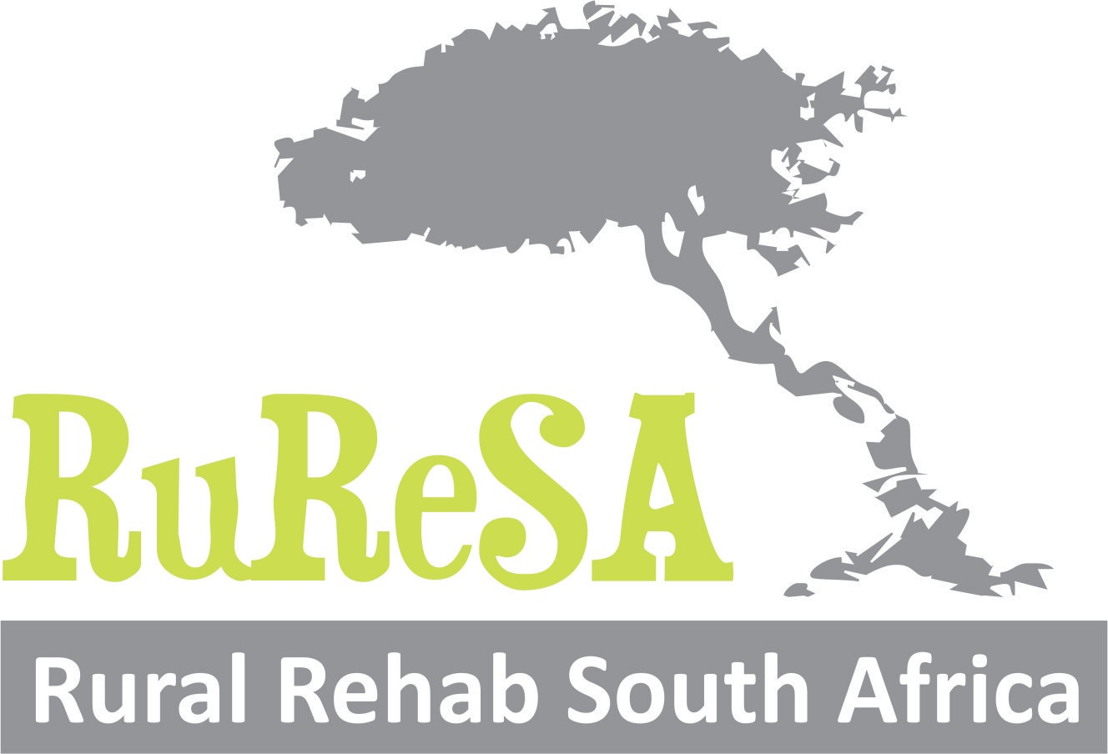ustom built chairs. Mpho set up his initial workshop at a local stimulation centre for children with disability. Here he made each of the children who required specialised seating an APT chair. There parents did not have to pay and Mpho only received the smallest stipend for his work. He also passed on his skills to one of the caregivers who worked together with him. Mpho was integrated into the centre and assisted the caregivers at the centre with other daily tasks. The time he spent there was instrumental in developing his understanding of the needs of disabled children and the challengers their caregivers face. It fired him up as he started to understand the importance and significance of the chairs he was making.

Out of all the people trained by MO, Mpho proved to be the most skilled and motivated. He travelled with Gillian to Lesotho to train others to make APT chairs. He also assisted a fellow “APTer” in KZN to kick start his business. Mpho spent time in Johannesburg at MO to make them some APT chairs.

In 2019 Mpho was shortlisted for the SAB Foundation for the Social Innovation and Disability Empowerment Award. Mpho won the Disability Empowerment Award as well as the best project, as voted by the audience on the night of the awards. This was a night of celebration but also the start of a very challenging period. Mpho had to deal with jealousies in his community once some members learned that he had won such a large sum of money. Then COVID intervened and slowed down many of his plans. But through it all Mpho has not given up and persevered under some very challenging and stressful situations. He has continued to make chairs throughout lockdown for children attending the Tintswalo CP clinic. Recently he obtained his drivers licence which will allow him to now buy a bakkie so that he can independently move about, collecting cardboard and delivering his chairs. He has started making chairs for Clothes-to-Good, a NPO who won the SAB foundation award in 2018. This has opened up new business opportunities and the potential to really grow his business.

Mpho is a humble but remarkable young man and his story is unique and really inspirational. He is always open about his mental health diagnosis and wanted to share his story to encourages others with similar challengers and also change attitudes. His determination to improve his own life has also resulted in him improving the quality of life of disabled children and their caregivers.